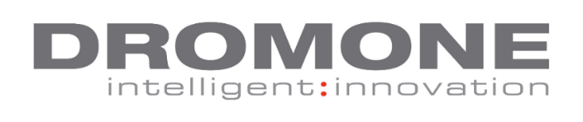
CNC OPERATOR VACANCIES
DROMONE is an Industry leading Irish company, developing hitch and coupler technology for the agricultural and construction markets. Our customers include Global OEMs such as Volvo, AGCO (MF and Valtra), JCB and SDF.

We are currently recruiting for the following vacancies: CNC Operators
Reporting to: Service Centre Manager
Job role: To manage and produce machined parts by programming, setting up, and operating CNC machinery, maintain quality and safety standards, keeping records, maintaining equipment and consumables in a busy manufacturing environment.
The key responsibilities of the role include:
- Plan machining by work schedules.
- Programming CNC machinery by entering instructions, including zero references positions.
- Production set up.
- Ability to read and interpret drawings and knowledgeable in geometric dimensioning and tolerances.
- Knowledgeable with tool / insert selection and utilizing the correct feeds and speeds.
- Good knowledge of dimensional measuring instrumentations and use of such tools to verify actual measurements of machined dimensions and features.
- Working knowledge of lean manufacturing techniques & principles and 5S.
- Adhering to quality procedures and process-familiar with ISO 9001: 2008.
- Planning & problem solving abilities.
- Maintain safe operations by adhering to all safety procedures.
- Maintain continuity between work shifts by communicating actions, irregularities with supervisor and fellow operators.
- Document actions by completing production and quality logs.
- Shift work will apply for this role.

What you need to succeed:
- At least 2 to 3 years experience as a machinist, with excellent functional and technical skills.
- Knowledge of Mazatrol Fusion, Master Cam, Reinshaw probing system, and Fanuc based ISO.
- Need to have good computer skills, particularly in Excel.
- Ideal industry background: automotive
- Have the ability to read and interpret documents such as safety rules, drawings, operating instructions and procedures to produce products to customer’s exact specifications.
- You must have strong organisational and communication skills.
Salary: Competitive rates depending on experience
To apply: email cover note and CV to recruitment@dromone.ie
Closing date 04/05/2018.

