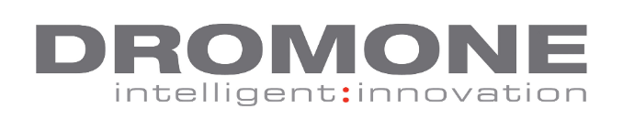
MIG WELDER VACANCY
DROMONE is an Industry leading Irish company, developing hitch and coupler technology for the agricultural and construction markets. Our customers include Global OEMs such as Volvo, AGCO (MF and Valtra), JCB and SDF.
We are currently recruiting for the following vacancy: MIG Welder
Reporting to: Agri Fabrication Team Leader
Job responsibilities:
- Must be able to weld a variety of material types and thickness from 3mm up to 80mm.
- Working from production drawings you will deliver high quality welding and fabrication to manufacture and produce products to the highest possible standard.
- Be responsible for the quality of the products before releasing to next step in the production process by visual inspection of welds to determine compliance with standards.
- Report any deviations from the required standard immediately to area supervisor so problems are quickly identified and addressed.
- Responsible for working to tight deadlines and have the ability to work under pressure.
- Shift work will be required for this position.
What you need to succeed:
- MIG Welders with prior production welding experience of at least 2 to 3 years (preferably certified).
- Have the ability to read and interpret documents such as safety rules, fabrication welding drawings, operating instructions and procedures to produce products to customer’s exact specifications.
- You must have strong organisational and communication skills.
Salary: Competitive rates depending on experience
To apply: Please email cover note and CV to recruitment@dromone.ie or post for the attention of the HR Manager, DROMONE Engineering, Dromone, Oldcastle, Co. Meath.
Closing date 04-05-2018.

